AI Blog Nest API Documentation Generate, manage and converse about blog content using AI.

Description
The AI Blo gNest backend is a secure, modular REST API platform designed to simplify blog creation, content management, and AI-assisted writing. Built with Node.js and Express.js, the application uses MongoDB as its primary database with Mongoose as the ODM layer for schema modeling, validation, and data access.
The platform integrates the Google Gemini API through a dedicated service layer to provide intelligent features such as AI-powered blog generation, AI-assisted content summarization, and a conversational AI chat assistant with persisted history, enabling users to create and explore content with minimal manual effort.
Security is a core part of the architecture: JSON Web Tokens (JWT) provide stateless authentication, bcrypt.js hashes and verifies passwords, and an authentication middleware protects sensitive routes by validating tokens and attaching the requesting user to every guarded request. The backend also supports full blog CRUD, threaded comments per blog, request-body validation with express-validator, and a centralized error-handling middleware that returns consistent JSON error responses.
Designed with a layered, modular architecture (routes → controllers → models), AI BlogNest serves as a lightweight, AI-augmented content backend that other frontends or clients (web, mobile, or API tools such as Postman) can consume over a simple set of REST endpoints.

Scenario-Based Case Study

Background
Priya is a content creator who manages multiple blogs but struggles to draft posts quickly, gather feedback from readers, and keep a record of her past writing conversations with an AI assistant.

Problem
- Drafting a first version of a blog post from a bare topic idea takes too long.
- Long-form articles are time-consuming to condense into short, shareable summaries.
- Reader feedback is scattered because there is no structured way to comment on individual posts.
- There is no secure way to control who can edit or delete a given post or comment.
- Prior conversations with the AI assistant are lost once the browser tab closes.

Solution
The AI Blog Nest backend delivers a centralized, JWT-secured API that separates business logic from any frontend. It introduces an AI Flow service (geminiService.js) that wraps the Gemini API for both one-shot generation tasks (blog drafts, summaries) and multi-turn chat, while ownership checks in the controller layer ensure only the author of a blog or comment can modify or remove it.

Usage
- Author Usage: Registers and logs in, creates blog posts manually or via AI generation, updates or deletes their own posts, and reads/writes comments.
- Reader Usage: Browses published posts through the public GET routes and posts comments once authenticated.
- AI Assistant Usage: Any signed-in user can ask the assistant to draft a blog from a topic, summarize existing content, or hold a running conversation whose history is stored per user.

Outcome
By moving content generation, validation, and access control into a dedicated backend, Priya can draft a usable blog post in seconds, keep every comment thread and edit tied to a verified identity, and pick up AI conversations exactly where she left off, since chat history persists in MongoDB per user.

1. Software Requirements
- Operating System: Windows 10/11, macOS, or Linux (cross-platform Node.js runtime).
- Node.js (v16 or above): JavaScript runtime executing the Express server and application logic.
- npm (v8 or above): Package manager used to install and run project dependencies.
- Express.js 4.x: Lightweight routing framework used to build the REST API surface.
- MongoDB: Document database storing users, blogs, comments, and chat history.
- Mongoose 7.x: ODM layer used for schema definitions, validation, and queries.
- Google Generative AI SDK (@google/generative-ai): Client library used to call the Gemini model.
- Postman or Thunder Client: API verification tools used to exercise every route with sample JSON payloads.
- Code Editor: Visual Studio Code or a similar IDE.

2. Hardware Requirements
- Processor: Intel Core i5 (8th Gen or above) / AMD Ryzen 5 or equivalent.
- RAM: 8 GB minimum (16 GB recommended for running MongoDB, the Node server, and the editor together).
- Storage: 1 GB of available disk space for dependencies and project files.

Epic 1: Project Architecture
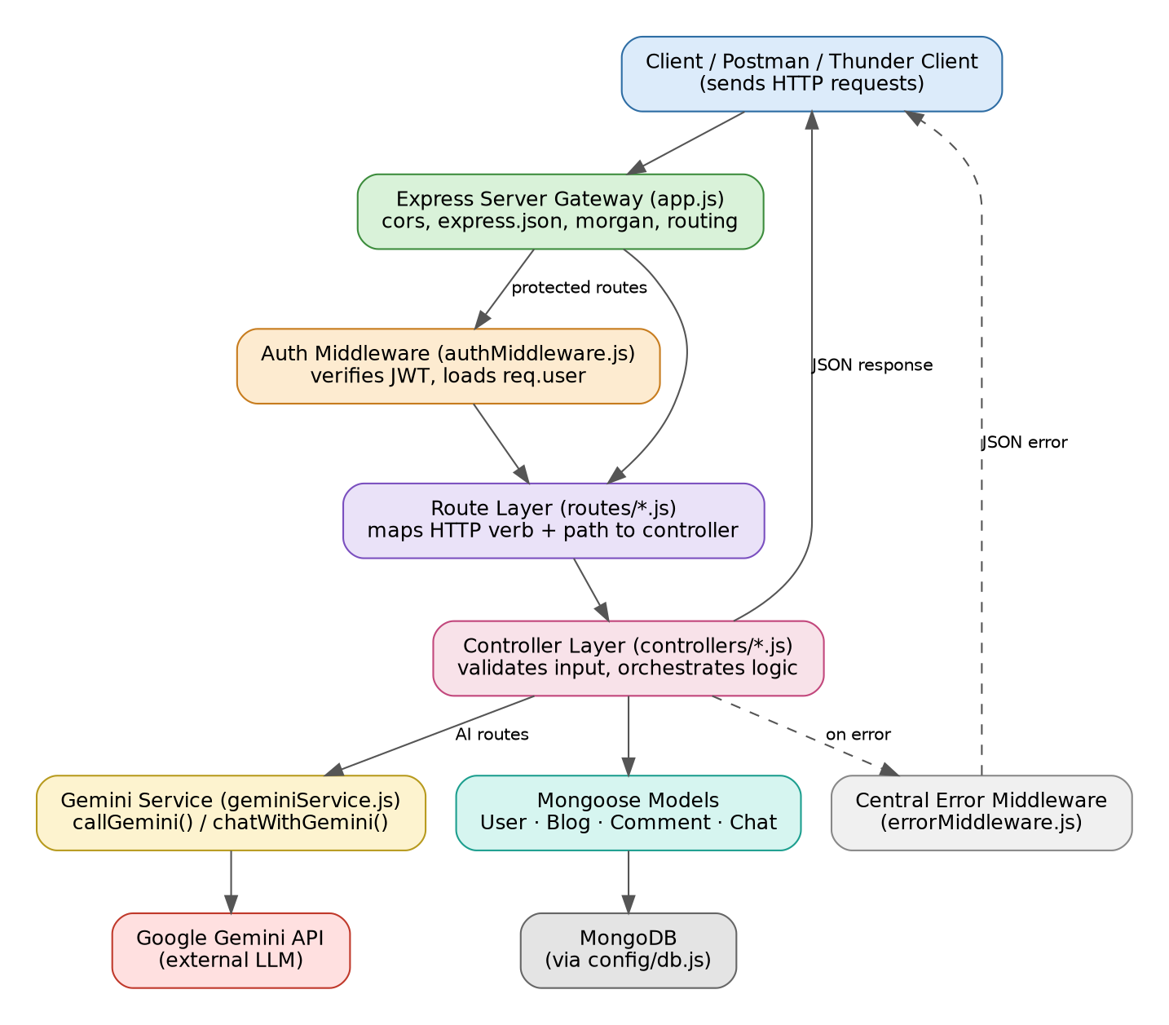
AI BlogNest exposes a layered REST API. Every incoming request passes through global middleware, is optionally authenticated, is routed to a controller, and is answered with a JSON payload — with a central error handler catching anything that fails along the way.

Components Definition
- Client (Postman / Thunder Client / any frontend): Issues HTTP requests to specific route paths and receives JSON responses.
- Express Server Gateway (app.js): Registers global middleware — cors(), express.json(), morgan('dev') — and mounts each resource router under /api.
- Authentication Middleware (authMiddleware.js): Reads the Authorization: Bearer <token> header, verifies the JWT with jsonwebtoken, loads the user from MongoDB, and attaches it to req.user for protected routes.
- Route Layer (routes/*.js): Maps each HTTP method and path to a controller function and declares express-validator rules for the request body.
- Controller Layer (controllers/*.js): Validates input, enforces ownership rules, talks to the models, and shapes the JSON response.
- Database Interface Layer (models/*.js + config/db.js): Mongoose schemas translate controller calls into native MongoDB operations over a single pooled connection.
- AI Flow — Gemini Service (services/geminiService.js): Wraps the Google Generative AI SDK behind two functions, callGemini() for one-shot prompts and chatWithGemini() for multi-turn conversations, so controllers never talk to the external API directly.
- Central Error Middleware (errorMiddleware.js): Registered last in app.js; catches anything passed to next(err) and returns a consistent { message } JSON error body.

Entity-Relationship (ER) Diagram Description
The application persists four collections, related through ObjectId references:
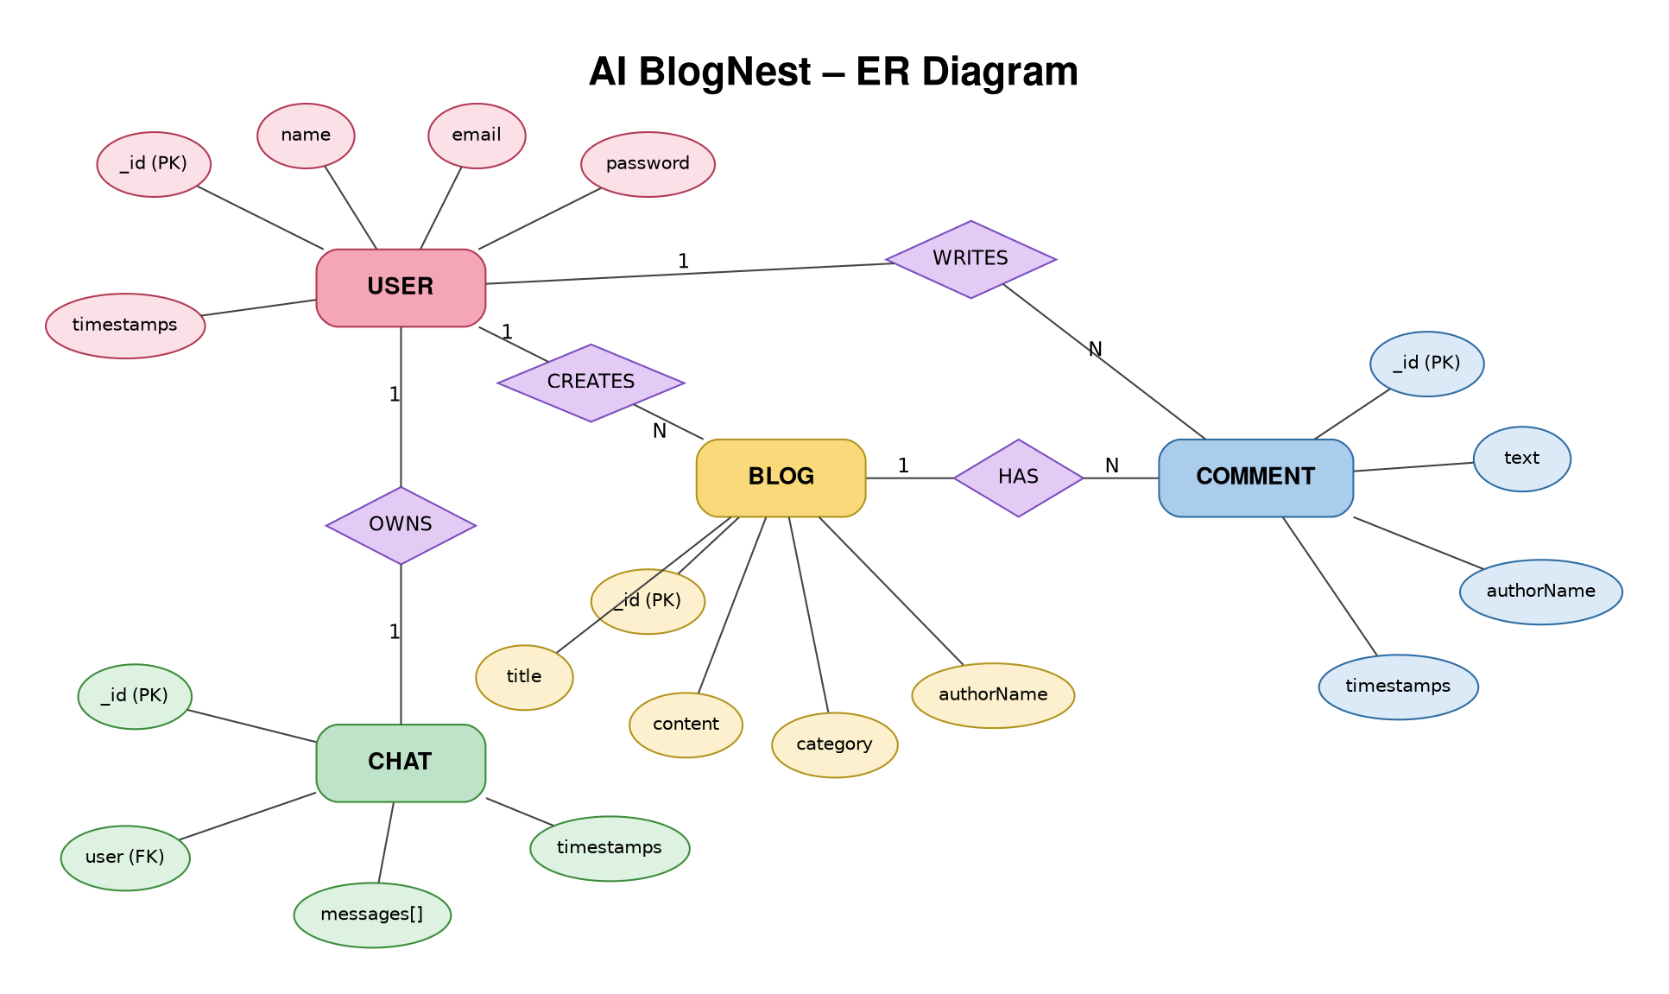

1. User Entity
- _id (Primary Key – ObjectId)
- name (String, required)
- email (String, required, unique, lowercase)
- password (String, hashed with bcrypt, required, min length 6)
- timestamps (createdAt, updatedAt)

2. Blog Entity
- _id (Primary Key – ObjectId)
- title (String, required)
- content (String, required)
- category (String, required)
- author (ObjectId, references User, required)
- authorName (String, required – denormalized for quick display)
- timestamps (createdAt, updatedAt)

3. Comment Entity
- _id (Primary Key – ObjectId)
- text (String, required, max 500 characters)
- blog (ObjectId, references Blog, required)
- author (ObjectId, references User, required)
- authorName (String, required)
- timestamps (createdAt, updatedAt)

4. Chat Entity
- _id (Primary Key – ObjectId)
- user (ObjectId, references User, required, indexed)
- messages ([{ role: 'user' | 'model', content: String, timestamps }])
- timestamps (createdAt, updatedAt)

Key Structural Mappings
- User to Blog (One-to-Many): An author can create multiple blog posts.
- User to Comment (One-to-Many): A user can post multiple comments across different blogs.
- Blog to Comment (One-to-Many): Each blog stores independently referenced comment documents.
- User to Chat (One-to-One): Each user has a single running chat document that accumulates message history.

Key Features
- JWT Route Guarding: The authMiddleware blocks unauthenticated requests from reaching protected controllers.
- Ownership-Based Authorization: Blog and comment updates/deletes check that req.user._id matches the resource's author before allowing the change.
- CRUD Blog Engine: Full create, read, update, and delete support for blog posts, including population of author name/email on reads.
- Categorization: Blogs carry a required category field, either supplied by the user or inferred automatically for AI-generated posts.
- Comment Threads: Comments are scoped to a specific blogId and support update/delete by their original author.
- Request Validation: express-validator rules on every write route return structured 422 errors before a controller runs.
- AI-Driven Blog Generation: POST /api/ai/generate-blog turns a short topic into a formatted 100–150 word draft, strips markdown artifacts, and auto-assigns a category via keyword matching when none is supplied.
- Content Summarization: POST /api/ai/summarize condenses any submitted text into a short, readable paragraph.
- Conversational AI Assistant: POST /api/chat/message keeps a rolling window of the last 20 messages as context and persists the full conversation per user.

Roles and Responsibilities
- Authenticated User (Author): Registers, logs in, creates and manages their own blog posts and comments, and uses the AI generation, summarization, and chat endpoints.
- Guest / Reader: Can read published blogs (GET /api/blogs, GET /api/blogs/:id) and summarize content without needing an account; posting a comment or creating a blog requires authentication.
The current schema does not implement a multi-tier role field (Admin/Editor/Author/Reader); authorization is enforced through JWT presence plus resource ownership, which is the access-control model actually implemented in this codebase.
User Flow:
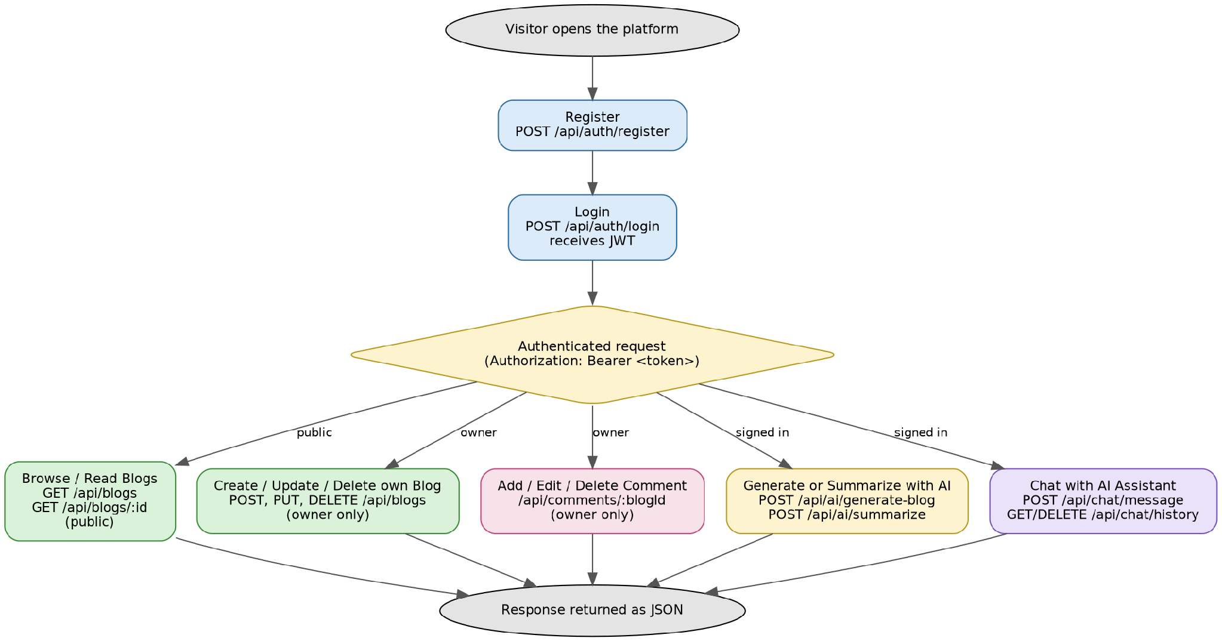

MVC Architecture Pattern
The source layout follows the Model-View-Controller pattern to keep data definitions, business logic, and routing fully decoupled:
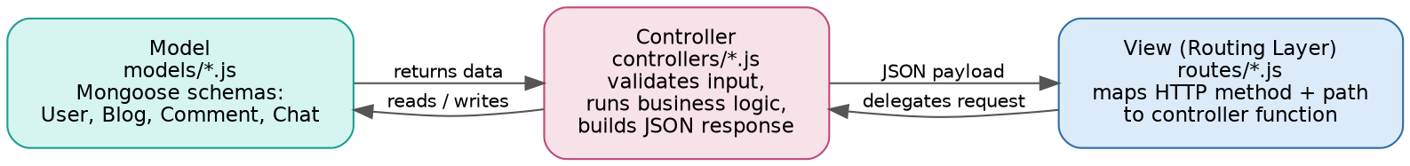

Model Layer (Data Blueprint)
Defined in models/*.js using Mongoose schemas (User, Blog, Comment, Chat). Each schema enforces required fields, defaults, string trimming, and reference relationships before any document is persisted.

Controller Layer (Execution Matrix)
Defined in controllers/*.js. Each controller reads the validated request, applies business rules (for example, checking blog or comment ownership before an update), calls the appropriate model methods, and returns a JSON response or forwards an error to next().

View Layer (Routing Network Interface)
As a headless API, there are no server-rendered views. The routing layer (routes/*.js) plays this role instead — it wires each HTTP method and path directly to its controller handler and declares the validation rules that gate it.

Epic 2: Project Setup and Configuration

Creating the project folder
- Create a new folder for the project (for example, ai-blognest-api).
- Open that folder in VS Code.
- Create a src/ folder to hold all application source code.
- Inside src/, create the config, models, controllers, routes, middleware, and services folders.

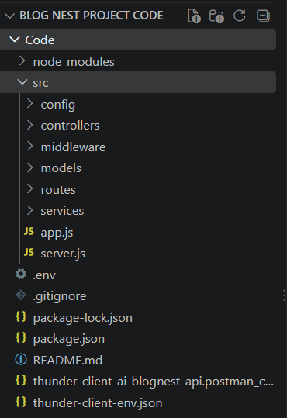

Server setup (npm init)
Open the project folder in a terminal and run:
npm init -y
Install the runtime dependencies:
npm install express mongoose cors morgan dotenv jsonwebtoken bcryptjs express-validator @google/generative-ai
Install the development dependency:
npm install -D nodemon
Create the entry files:
- src/server.js – boots the app and starts listening.
- src/app.js – configures Express, middleware, and routers.
Add the run scripts to package.json:
"start": "node src/server.js"
"dev": "nodemon src/server.js"

Epic 3: Backend Development

server.js
Loads environment variables, connects to MongoDB, and starts the HTTP listener only once the database connection succeeds:
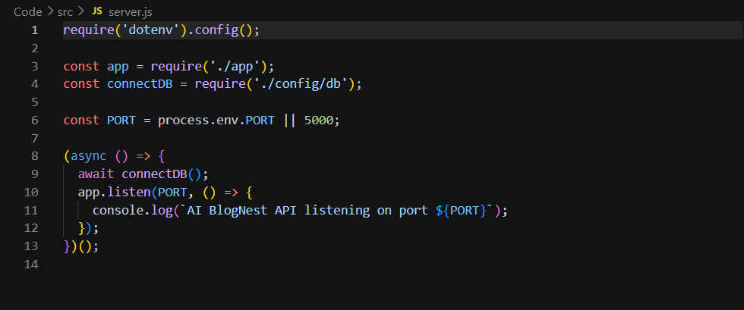

app.js
Configures global middleware, mounts the five resource routers under /api, exposes a health-check root route, and registers the central error handler last:
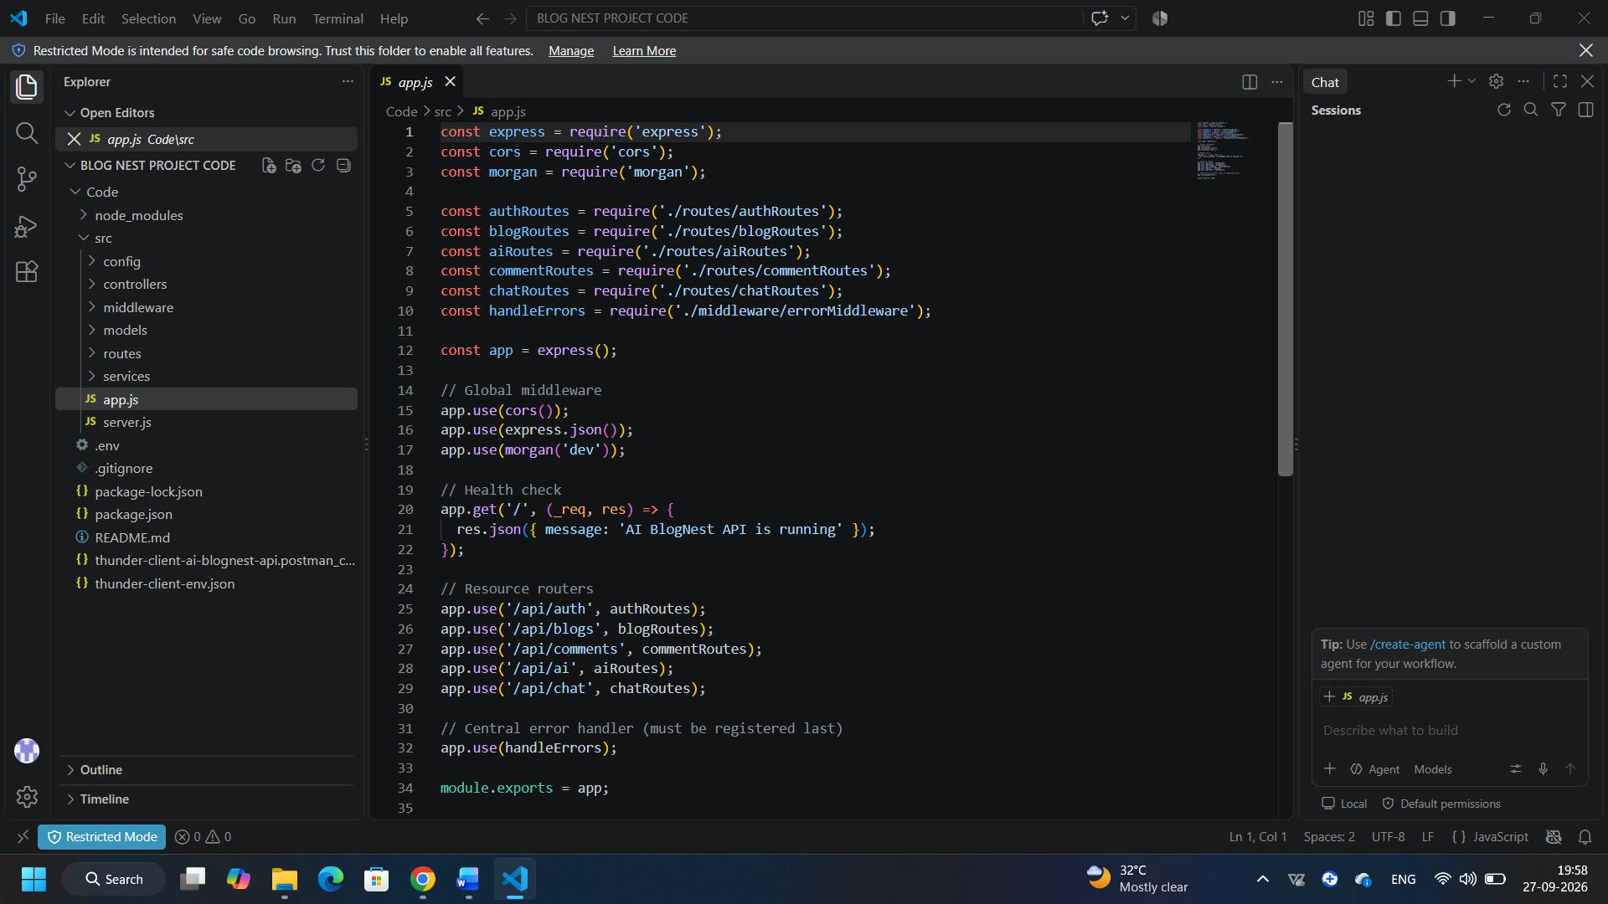

Epic 4: Database Configuration

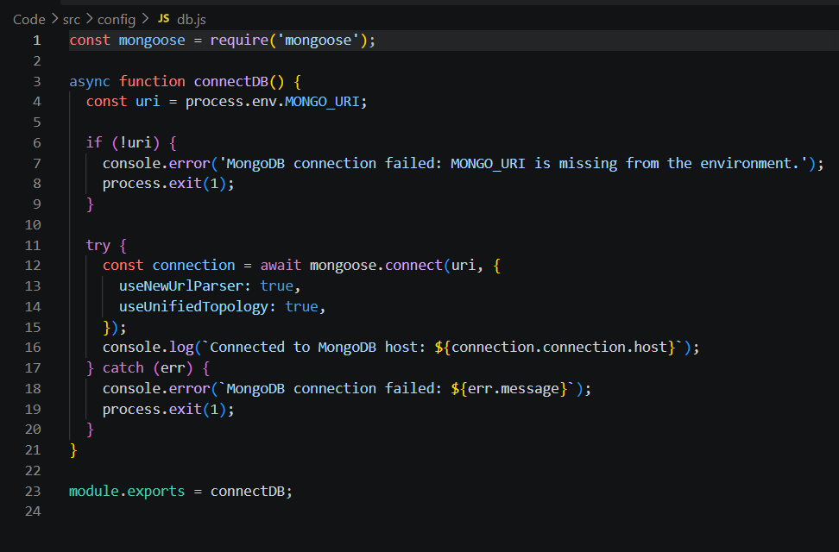

DB Connection

1. Configure MongoDB
Install Mongoose in the project directory:
npm install mongoose
- Create the database connection module (config/db.js).
- Create the Mongoose schemas and models (models/User.js, Blog.js, Comment.js, Chat.js).

Create Database connection
The database must connect successfully before the server starts accepting requests. server.js awaits connectDB() and only calls app.listen() once that promise resolves; connectDB() itself exits the process if MONGO_URI is missing or the connection attempt fails, so misconfiguration fails fast instead of silently.

Mongoose Schema Definitions

1. Identity Resource Document Schema (models/User.js)
Enforces field validation on every incoming user document:

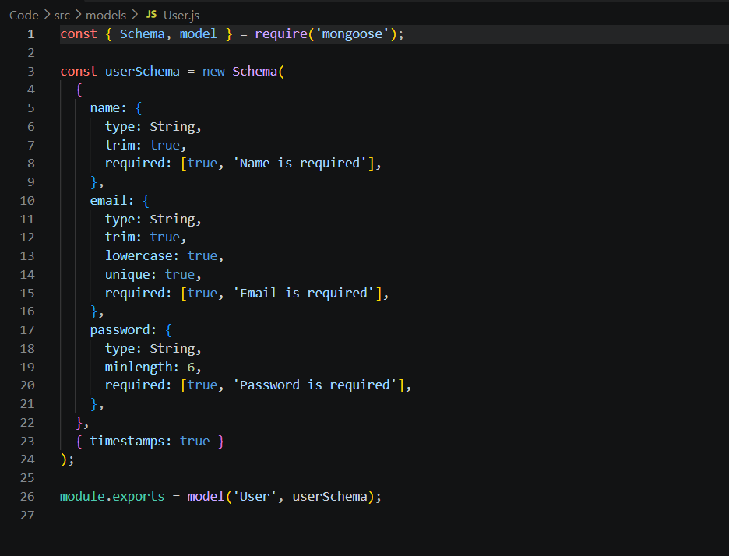

Epic 5: Project Executions
- Install Postman or the Thunder Client extension for VS Code.
- Create a .env file with PORT, MONGO_URI, JWT_SECRET, GEMINI_API_KEY, and GEMINI_MODEL.
Start the backend server:
npm run dev
The included Thunder Client collection (thunder-client-ai-blognest-api.postman_collection.json) exercises every endpoint below with ready-made sample payloads.

API Testing
The panels below show representative request and response payloads for the core flows, reconstructed from the project's Thunder Client collection and controller logic.

User Registration

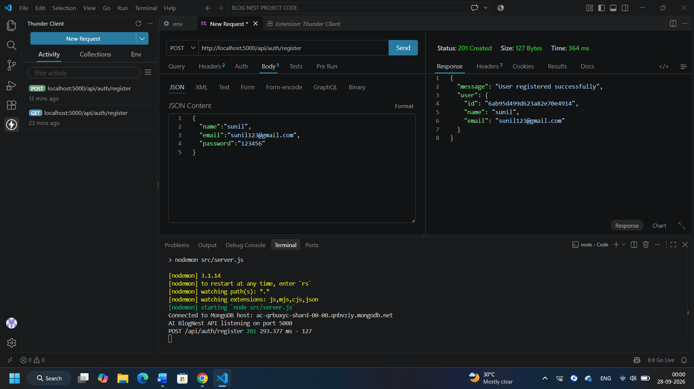

User Login

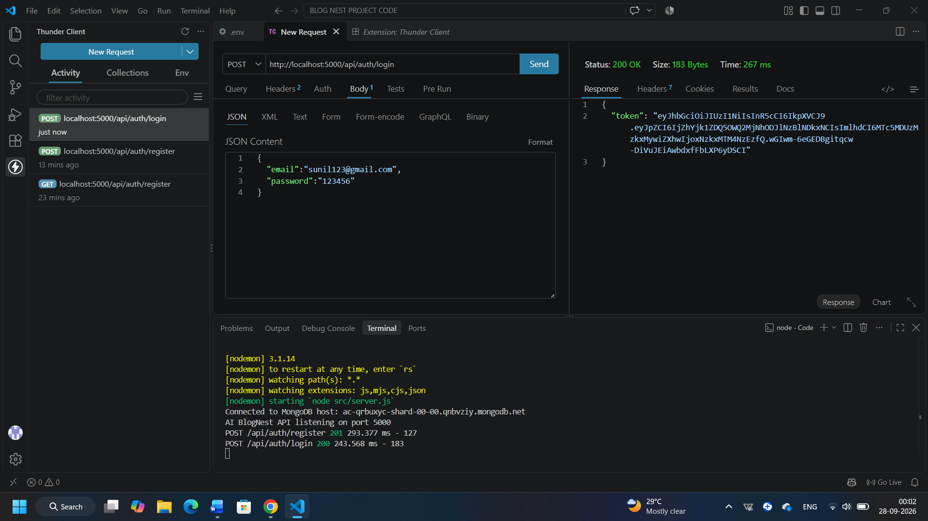

Create Blog
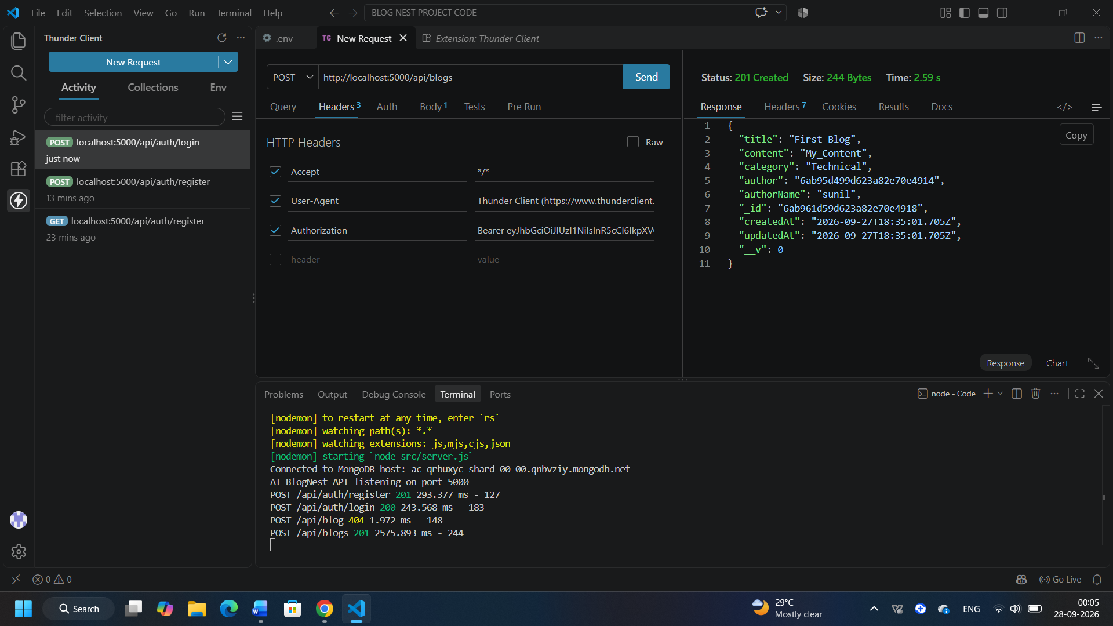

Fetch Blogs
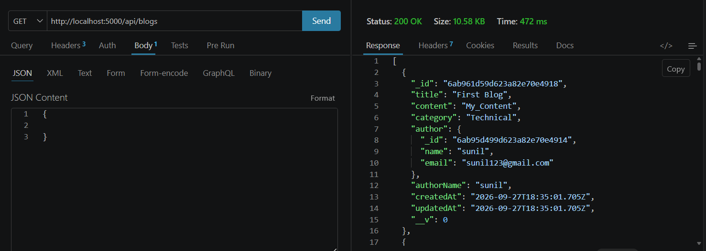

Generate AI Blog

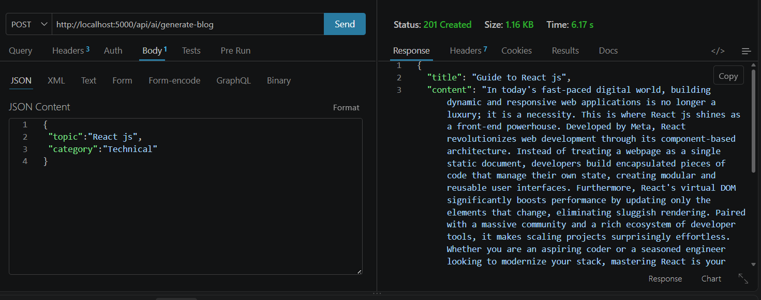

Summarize Blog

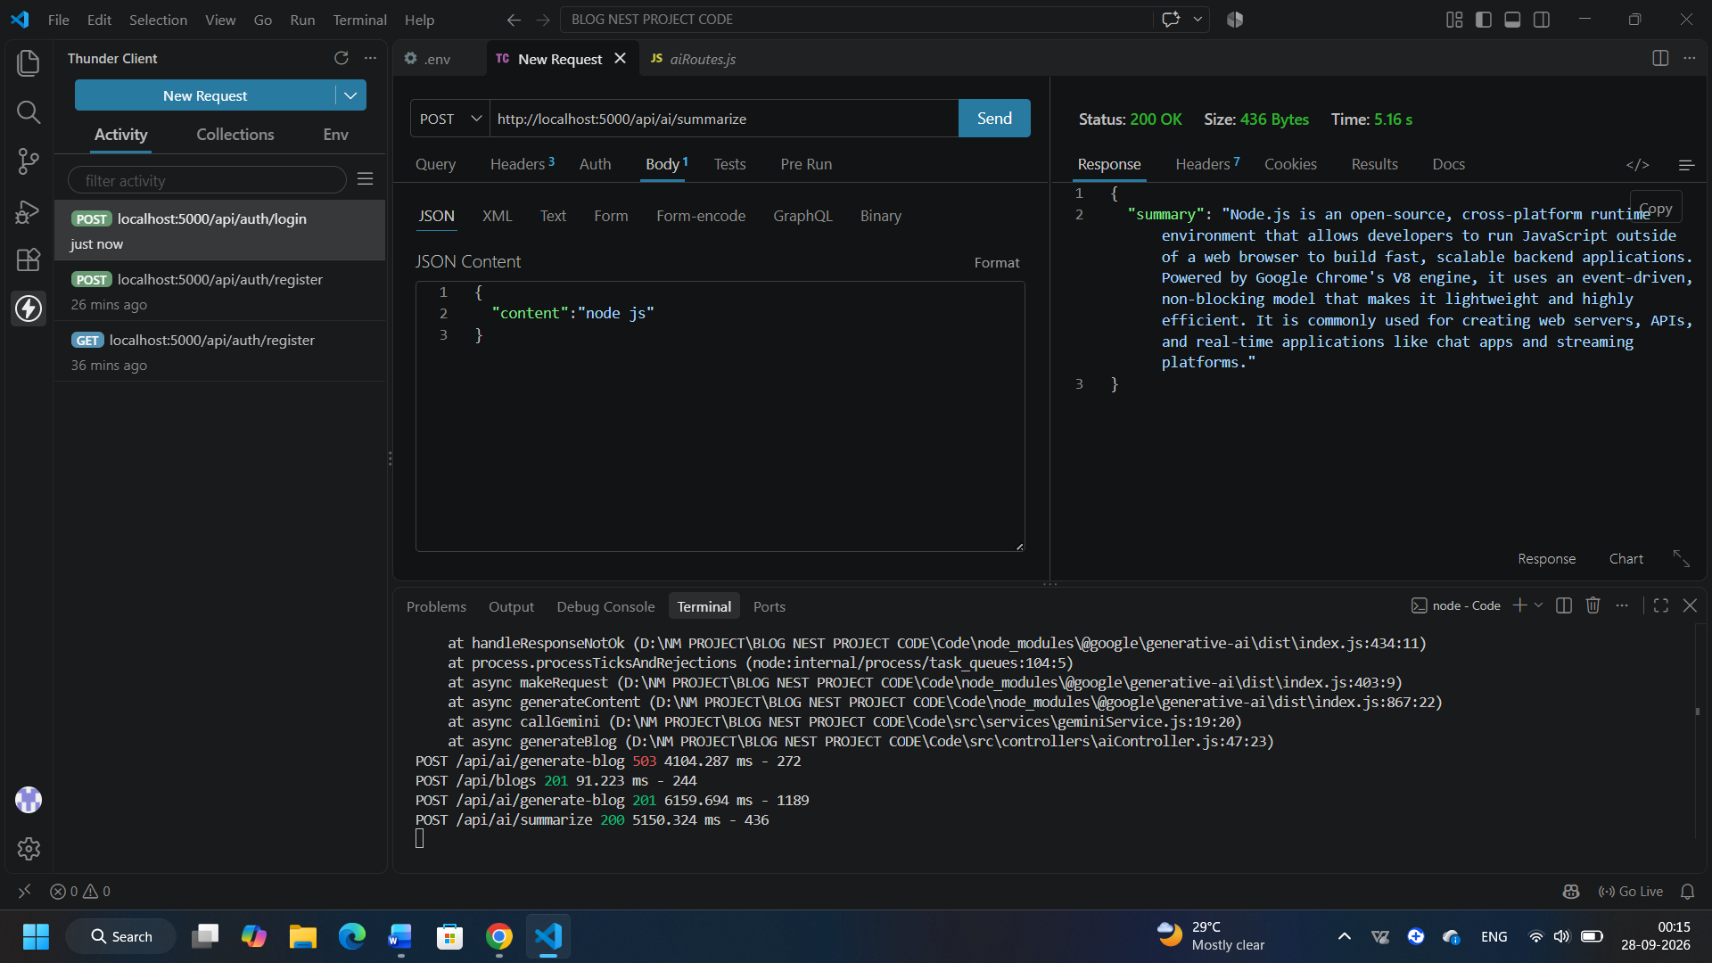

Demo Video:Demo video

APITesting: Demo video

Code Drive: Ai Blog Nest Project Code

